Child Safeguarding Incident Report Form
This form must be completed by any adult who identifies child protection concerns
- All child protection cnocerns must be reported to the Designated Safeguarding Lead (Liz Green)
- Record facts. Don’t make judgements. State date, time place, actual words, what was observed, who was present, question asked.
- Do not delay. Seek support if you need help filling in this form.
- Any concerns about youth leaders or members of the church must be reported immediatley to the DSL. Concerns about the DSL must be reported to the Elders or MARAT (see policy for contact details)

Details of the incident
Date and time of incident
Child’s name
Date of birth
Summary of incident or discussion
Signed

Print name
Date

Indicate the position of any marks observed
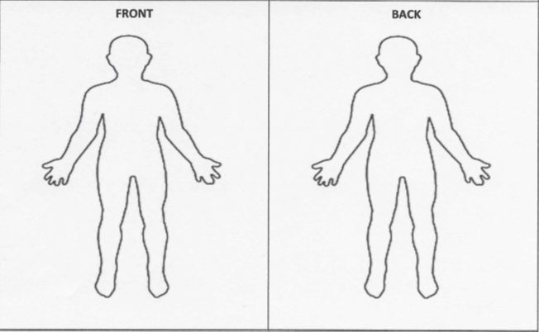
Action taken by the adult/youth leader
Action taken by DSL (Reason for concern, decision made, action taken/to be taken)
Signed by DSL

Print name
Date

